Technical Guidance For Completing The Online Form

- Which devices to use when completing your form
- We strongly recommend using a laptop or desktop Windows or Mac device rather than a mobile device (phone or tablet) as some sections like file attachments might not display properly.
- We recommend using almost any browser apart from Internet Explorer. Chrome, Firefox, Edge or Opera work fine.

- Scrolling between pages on the form
- If you need to move back or forward between pages on the form you should you use the #previous page’ and ‘next page’ buttons at the bottom of each page. Do not use the back button on your browser as you risk losing any unsaved work.
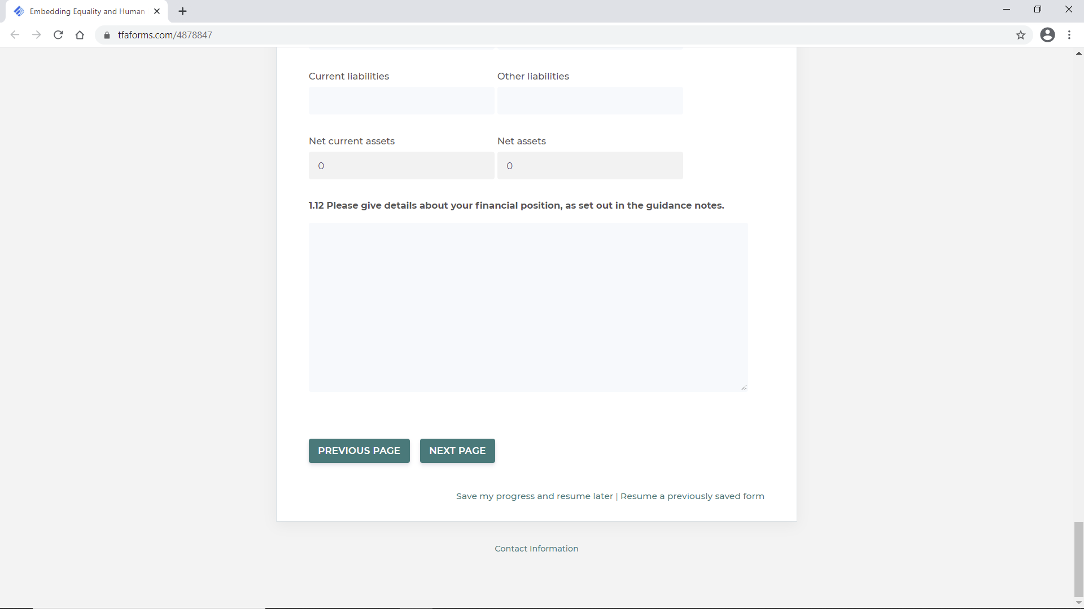

- Mandatory Questions
The majority of questions in the application are marked as mandatory to avoid you missing questions. All mandatory questions are marked with a * after them
E.g. 1.1. Legal Name of Your Organisation*

If you miss a mandatory question by accident, the form will flag this to you when you hit the ‘submit’ button at the end
- Saving your progress
- You can save your progress at any point, by clicking on the ‘Save my progress and resume later’ box
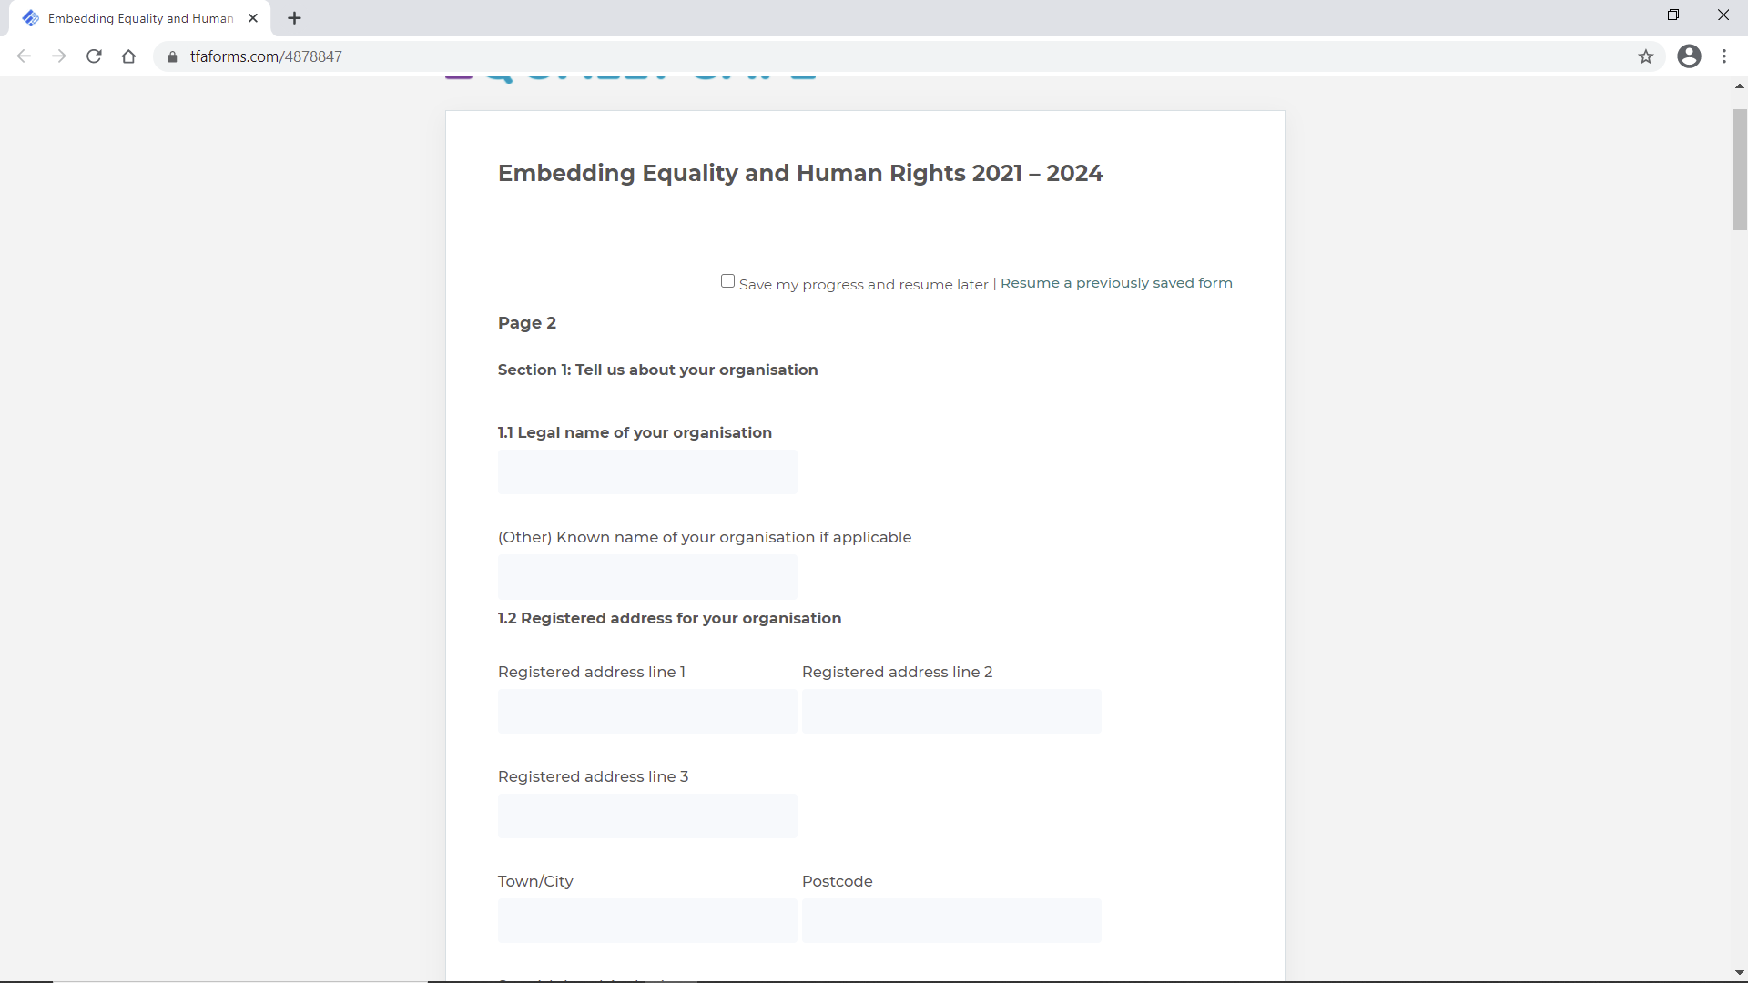
- After clicking on that, you will be asked to provide an email address and create a password. (see image below)
- It is really important to keep a note of these as you will need them to get back into your form.
- Please do not change the email address and password you originally used – keep the details the same throughout the process
- WE STORNGLY RECOMMEND SAVING YOUR FORM REGULARLY

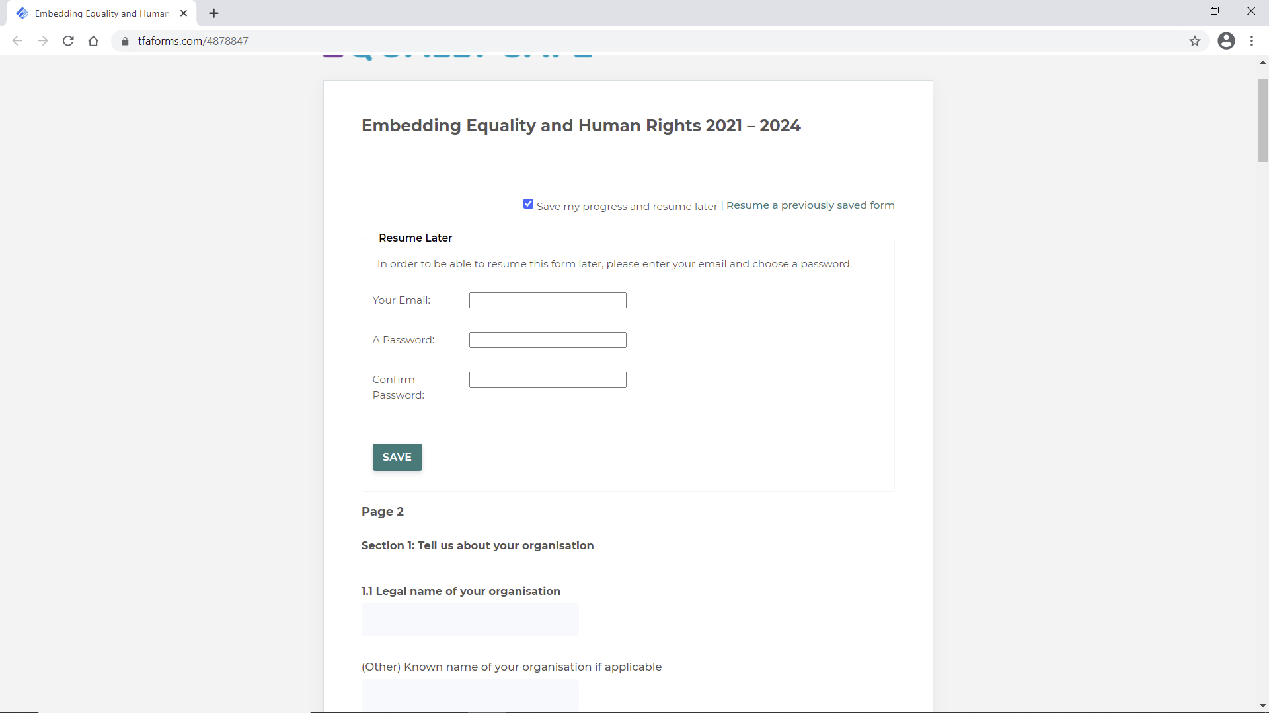

- Returning to a saved form
To return to a saved form, click on ‘Resume a previously saved form’ and then enter the email address and password you created.
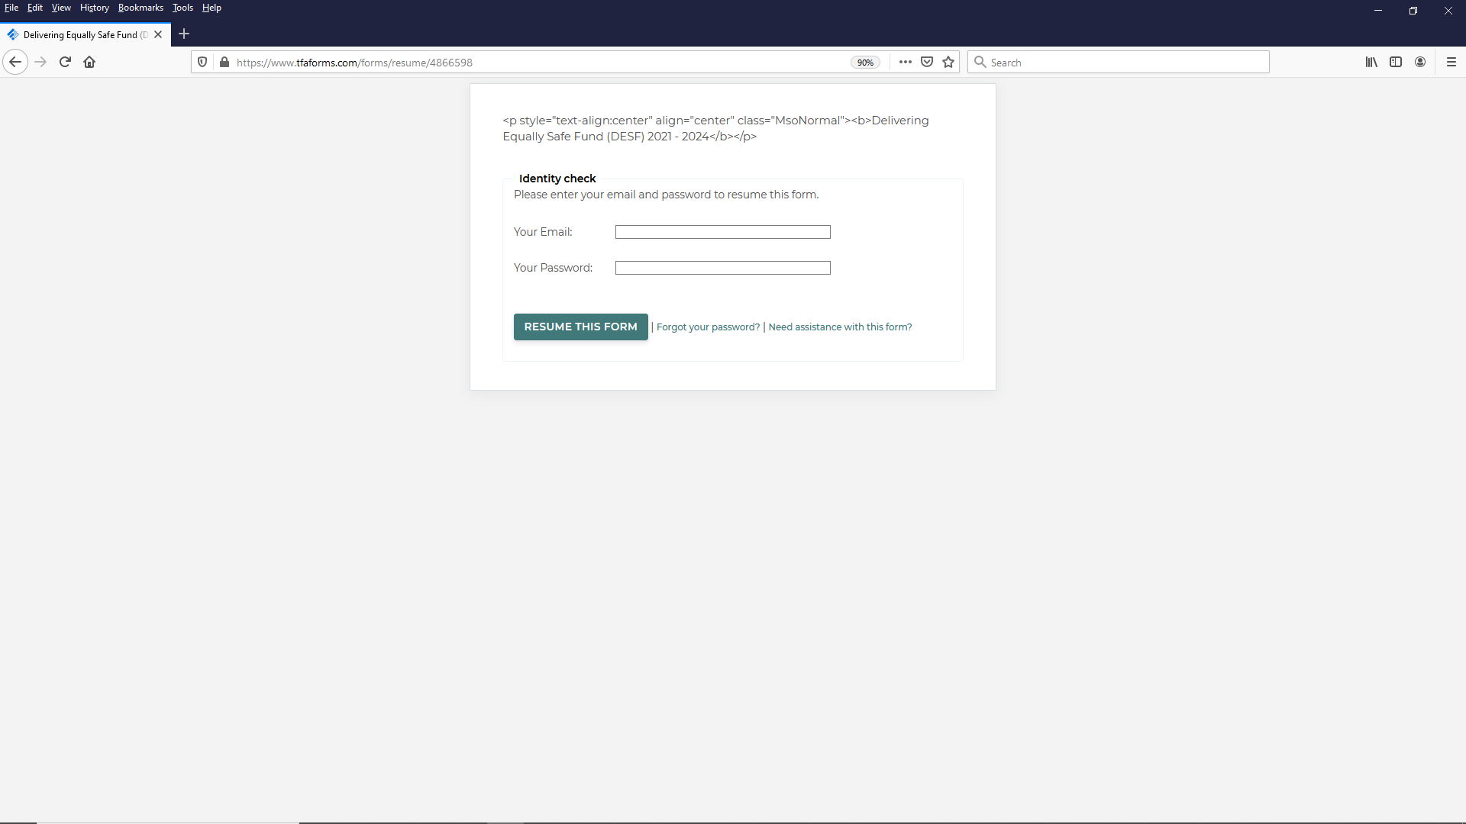

- Responses which require numbers
- In some questions – for example 1.6. The response must be in numbers only. So if you have 10 board members, type 10, not ten. You only need to provide the number and no further explanation to this, e.g. which roles they perform. Anything other than a number will result in an error being shown and you will have to go back and fix it.
- When entering numbers
  - You don’t need to add comas – you can enter 10000 instead of 10,000
  - You don’t need to add £ symbols

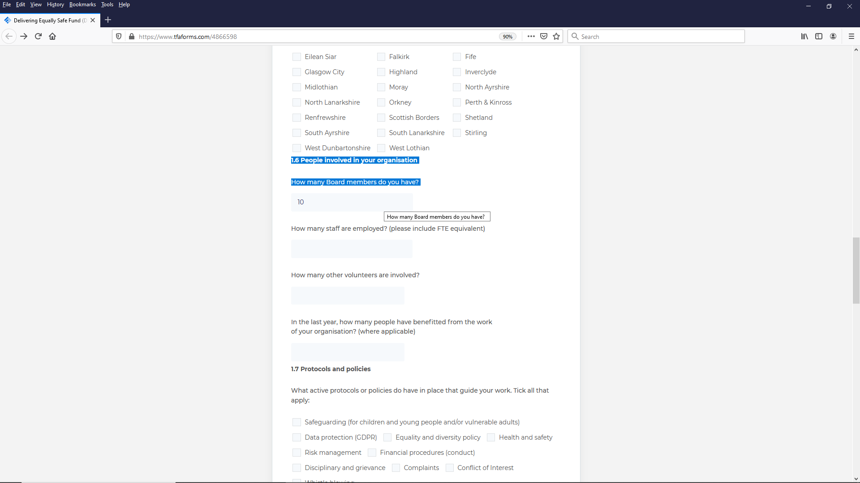

- For questions where you are asked for financial figures you can enter two decimal places
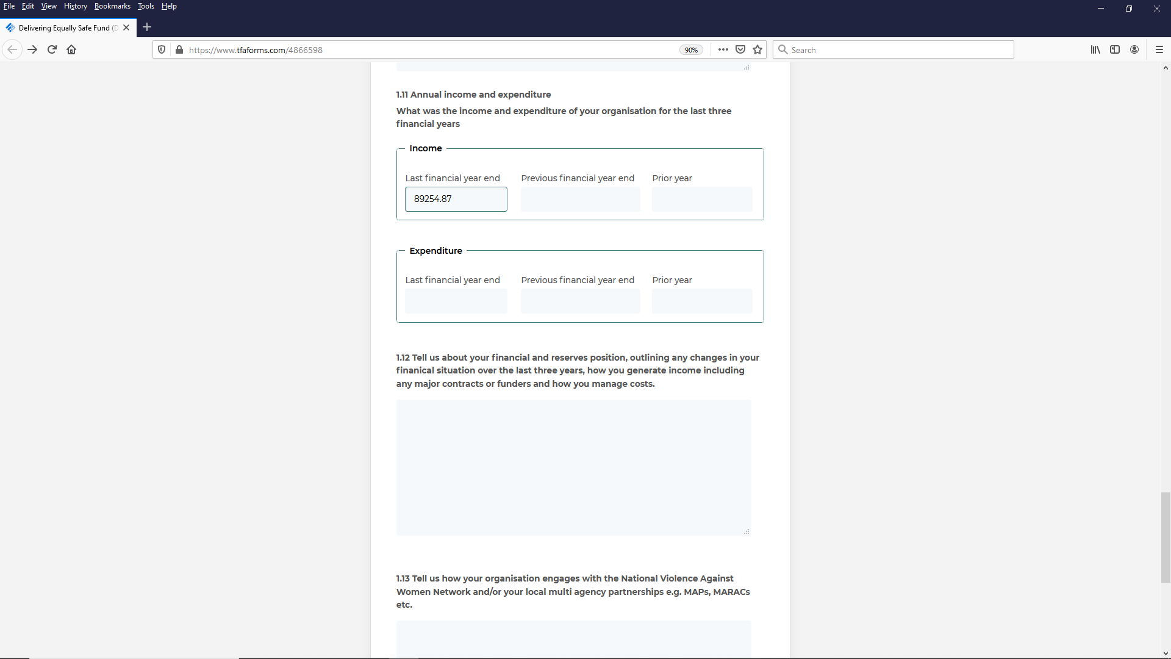

- Questions where you can or need to add more than one response
- In some questions, e.g. Sections 3.1 and 4.3 – you might want to or need to add more than one response. After completing all the fields for the first one you can then click on ‘Add another outcome’ This will then open up another section with the same fields repeated for you to add another outcome.
- This works the same for other questions although the wording might be different
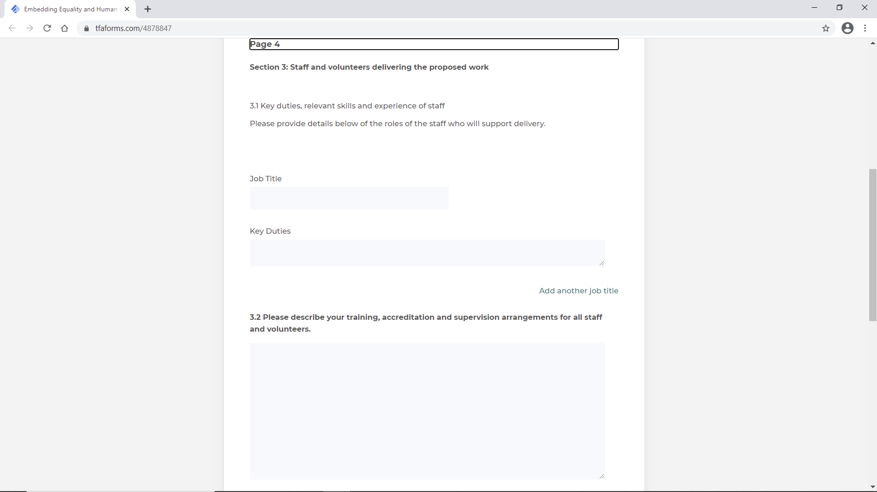

- Uploading attachments
The final section of the form requires you to upload several documents.
- To do this, click on Browse on a field, and locate the document/file form wherever it is saved, then double click it.
- The form will attach your document.
- You will know it’s done as the file name will appear there. In the example below, a document called ‘Test’ has been added
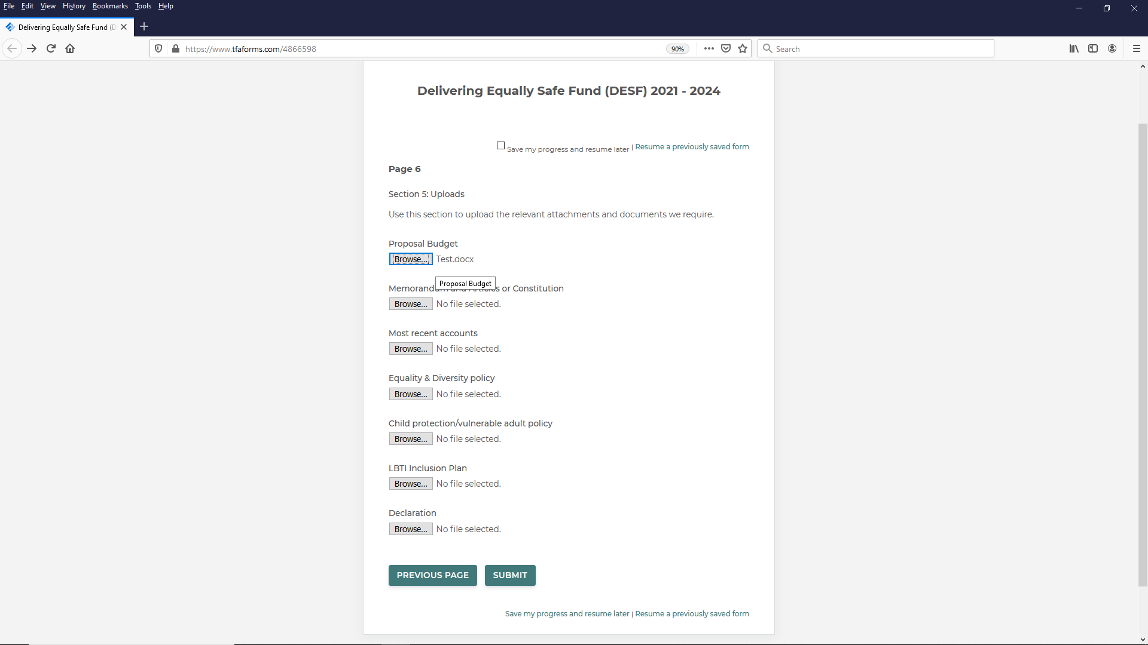

- Submitting your form
Press ‘Submit’
You then have a final chance to review your response. Read through to check everything and then either click
Submit, or,
Make a correction
(you can also choose to print the review page if you like)
You will receive an email confirming receipt of your form at the email address provided in Q1.3. This email will also provide a text copy of your answers.
If you do not receive this, can email enquiries@inspiringscotland.org.uk to confirm.

- Problems or errors with the form
If you have any issues with the form you can request support to enquiries@inspiringscotland.org.uk

