Time to Shine with Thrive

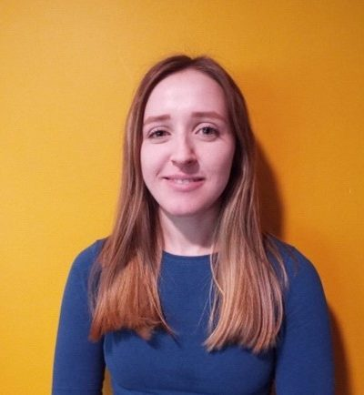
Jane joined Thrive Outdoors three months ago as Development Support Officer through the support of the Rank Foundation’s Time to Shine programme, which aims to support young people to become future leaders. Jane reflects on the experience so far and what she is looking to focus on for the rest of her time with Thrive.

Joining Thrive Outdoors
I joined Thrive Outdoors three months ago as Development Support Officer through the support of the Rank Foundation’s Time to Shine programme, which aims to support young people to become future leaders. The programme is a 12-month leadership and development placement within a charity to develop through the job role as well as leadership training and action learning sets.
The opportunity to join the Thrive Outdoors team at Inspiring Scotland supporting the development of high-quality, accessible outdoor play and learning for rural and remote locations has excited me the most. But on the flip- side, there has been a lot to learn, so I have thrown myself into the deep end, developing my understanding of the third sector and the benefits that come with the connection to the landscape and environment.
First Impressions
There is a great people focused culture here at inspiring Scotland. What has really struck me is the support to have a good work-life balance and to be able to fulfil your potential. There is a wellbeing group run by team members where they organise activities for you to build your passions and interests, get to know your colleagues more, gain new skills and have fun. Having this wellbeing group in place creates a supportive, collaborative and happy working environment.
I was also provided with a buddy, who I could contact for help and guidance. This proved to be very useful as they helped me with report writing, and formatting, language and editing, which has really been helpful going forward and doing other reports. Having a buddy has been great as this person is there when I have lots of little questions to ask.

Challenges and Achievements
The role so far has had a focus on research and report writing both of which I initially found to be difficult tasks as my college course and previous work to date had been mainly practical.
I found research difficult as it required a lot of focus and I had to adapt to understand the context of all the publications as they were new topics for me. As this work developed, I built a better understanding of the context of the sector and can now pick out key information easily.
I'm enjoying getting to do more written based work and improving my communication skills, which is why I'm here - doing this placement so that I can develop this side of me and these skills that I want to excel in. Writing in particular has been a challenge for me, which is also why I have been asked to write this blog about my experience so far.
Writing this blog piece has been more challenging than I anticipated because it's about myself and communicating my thoughts isn’t my strength. There was a time in my life when I wanted to be a writer and wrote often. That previous passion is why I’m enjoying developing this area so I can communicate confidently.
Next steps will be to work on
- My writing style, the language and formatting of reports/publications
- Confidence and communication skills
- Event organisation skills
- Marketing and branding
My ultimate goal is to become super-efficient in my work and build my confidence.
I am already feeling the improvement, and others are seeing this too and I’m excited to see how different I will be at the end of the year. Over the Summer months I am planning on getting out more to visit charities and organisations and to begin to put our research into practical action. And I’m excited to use the skills and knowledge I have gained so far.

