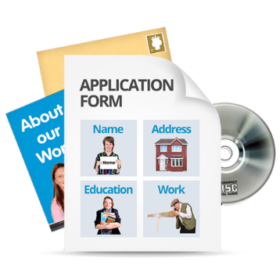
Our Future Leaders
Application Form
Course begins August 29th 2023

If you are interested in applying please fill in this form.

The deadline for application is Friday 29th July 2023.
You must send your application to us before then.

You will be asked to do a short interview on Zoom.
This is to get to know you a bit and find out more about why you want to do the course.
Then we will decide who gets a place on the leadership course.

Not everyone will be chosen because there is not space on the course for everyone.

Application Form

What is your name?

What is your address and postcode?

What is your telephone number?

What is your email address?
You will need to be able to use email for the course. Your links to the Zoom sessions will be sent by email.

Why are you interested in becoming a leader?

Please write your answer in the box below:

Do you need anything to help you to read and understand written information?

Please write your answer in the box below:

Everyone in the course needs to have a sponsor.
Please look at the easy read information on who a sponsor can be and what they need to do
If you do not think you can find a sponsor please email us and we will help you

If you know who your sponsor is please write their name and contact information in the box below:

Please email your application to us by Friday 29th July
albany@inspiring scotland
oflenquiries@inspiringscotland.org.uk marion.s@scld.co.uk

Thank you for taking the time to send us your application.

