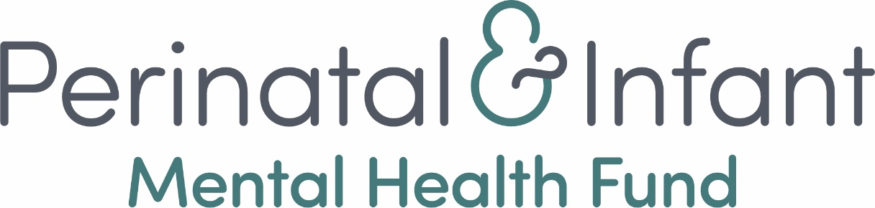

Perinatal and Infant Mental Health 2024 Fund

Fund Information and Guidance Notes
Including: Technical support on completing the online application form

Contents
Section 1 - Perinatal and Infant Mental Health 2024 Fund Information 3
About the fund 3
Key information 3
Background 4
National context 5
PIMH 2024 Fund aim and criteria 6
Who can apply 6
Partnerships 7
Governance arrangements and current funding 7
What will be funded – fund criteria 7
Requirements around safe, responsible practice 8
Integrating a trauma informed approach 9
PIMH 2024 Fund impact 9
Measuring impact 11
PIMH 2024 Fund outcomes contribution to national context 12
PIMH 2024 Fund application information 14
Fund duration 14
Funding available 14
Expectations of successful applicants 15
Application support available 15
Assessment and decision making process 15
Fund priorities and decision making considerations. 16
Key Dates 16
SECTION 2 - Guidance on completing the PIMH 2024 Application 17
Part 1 – Tell us about your organisation. 17
Part 2 – Tell us about the activities you would like funding for 20
Part 3 – tell us about the budget and funding request 23
Part 4 – authorisation 24
Technical guidance for completing the online application form 26
End Notes 29
Resources 29

Section 1 - Perinatal and Infant Mental Health 2024 Fund Information

About the fund
The Scottish Government’s Perinatal and Infant Mental Health (PIMH) 2024 Fund is an 18-month funding programme for third sector organisations who support babies, parents and carers affected by, or at risk, of perinatal and infant mental health issues in Scotland. This programme is a new round of funding, a continuation of the support offered through the PIMH Fund which was launched in 2019.
To date, the PIMH Fund has invested £2.8 million in 34 third sector organisations, supporting the mental health of babies, parents and carers across Scotland. This programme included a main and small grants fund, which has impacted over 10,000 people, including families, practitioners and volunteers. Read more about this transformational work in the latest fund report.

Key information
- Applications are invited from incorporated third sector organisations who are currently delivering Perinatal and Infant Mental Health support.
- The funding will enable direct service delivery for organisations who offer peer support, parenting and infant support and/or counselling/psychological support.
- Up to £500,000 will be allocated to the PIMH 2024 Fund from October 2024 to March 2025, and up to a further £1million from April 2025 to March 2026.
- Applicants can apply for a maximum of £132,000 for the duration of the 18-month fund split proportionately across the two financial years, being £44,000 for six months in 2024-2025 and £88,000 for 12 months in 2025-2026.
- Funding allocated will be spread across a range of grant sizes. Across the 18-months, organisations can apply for:

  - Band 1: between £100,000 - £132,000
  - Band 2: between £50,000 - £99,999
  - Band 3: up to £49,999

As a guide, we anticipate funding between five and eight organisations within each of these funding bands.
- Applications will be accepted from new applicants as well as organisations that are currently, or have previously been, funded through the PIMH Fund.
- Applications will be submitted via an online form. To get a link to the online application form, please express your interest here: PIMH Fund - Expression of Interest Form - 2024 (alchemer.com).
- With limited funding and a high demand for services, we are anticipating that this fund will be oversubscribed. A Decision Making Panel will ensure that the portfolio of successful charities has a good geographic coverage and supports a range of services, focused on those who are at a higher risk of developing perinatal and infant mental health issues.

Applications will close on Friday 3rd May at 12pm (noon). Decisions will be communicated to successful organisations by the end of June 2024.

Inspiring Scotland is managing the application process. If you have any questions or require support, please contact: pimhenquiries@inspiringscotland.org.uk
Accessibility
We want this information and application to be as accessible to as many people as possible. If there are barriers to you accessing the Fund information or application form, please get in touch.

If you prefer to speak to someone, please phone 0131 442 8760. The team at Inspiring Scotland work remotely so you may need to leave a message with the name of your organisation, the best number to reach you on and that your query relates to this Fund.

Background
Mental ill health in the perinatal period covers a range of conditions, including depression and anxiety, and can affect people of all ages and backgrounds. It has an impact on both mothers and fathers, with up to 20% of mothers and up to 10% of fathers affected at this crucial stage of life.
We also know that an infant’s most important developments, physical, cognitive, and emotional, have their foundations set very early in life. Specifically, from the beginning of pregnancy through to a child’s second birthday. It has been recognised that there is a lack of research to understand the prevalence of mental health issues for babies and infants. A meta-analysis based on ten epidemiological studies published between 2006 and 2020 estimated a 20% pooled prevalence for any mental disorder in children ages 12-83 months (7-years).
It is therefore a vital time for the whole family. Protecting the health of parents and carers at this time of huge change, facilitating their adaptation and recovery and building important parent infant relationships, is fundamental to good infant mental health.
The earlier the support is provided the better. The Scottish Government’s Early Child Development Transformational Change programme recognises that the period from pre-birth to three is a critical window, when the brain and metabolic and immune systems develop fastest, laying the foundations for life. Evidence shows the four things that are needed for babies and young children to develop are:
- sensitive responsive caregiving
- play and stimulation
- nutrition and health
- safe from harm

Support to infant and carers’ mental health contributes to all four of these. We know that early experiences have lasting impacts for childhood and beyond. Investing in and building up the services that support babies and new and expectant parents and carers is central to this.

National context
The Scottish Government is committed to ensuring equitable, coordinated access to mental health provision for infants and their parents and carers throughout pregnancy and the postnatal period.
Since the launch of the PIMH Fund in 2019, there have been significant developments in Scotland.
In 2023, the Scottish Government and COSLA jointly published a refreshed Mental Health and Wellbeing Strategy. This strategy is built around a ‘life stage model’ (shown on page 12 /Figure 3), featuring perinatal mental health care, parent-infant relationship care and infant and early years mental health care. The strategy is accompanied by a Delivery Plan which outlines the actions needed to achieve the aims of the Mental Health and Wellbeing Strategy.
The PIMH 2024 Fund outcomes will contribute to the Mental Health and Wellbeing Strategy and cross-cutting Government priorities such as The Promise, Best Start Bright Futures, GIRFEC and UNCRC. (see figure 4 on page 13). It will also contribute to National Performance Framework Outcomes:
- We grow up loved, safe, and respected so that we realise our full potential and
- We are healthy and active

In addition to a Women and Families Mental Health Pledge, created by women with lived experience to improve care for babies and families, in 2023 the Scottish Government published an Infant Pledge and Voice of the Infant Best Practice Guidelines. This document was published to help achieve a rights-based approach to infant mental health work in Scotland and to provide guidance on how to take into account infants’ views and rights in all encounters with professionals.
A new Joint Strategic Board for Children and Family Mental Health, co-chaired by the Scottish Government and Convention of Scottish Local Authorities (COSLA), provides strategic oversight for national Perinatal and Infant Mental Health support in Scotland.
To support the governance of the PIMH 2024 Fund, Scottish Government Policy Officials and the Fund Manager will report on progress to the Joint Strategic Board with updates and learnings from the funded organisations and to support connectivity with statutory services and wider programmes.

PIMH 2024 Fund aim and criteria

The aim of the PIMH 2024 Fund is:
To sustain and improve third sector, non-clinical* support for babies, parents and carers affected by, or at risk of, perinatal and infant mental health issues in Scotland.
Funding will support and strengthen new third sector organisations which support the mental health of babies, parents and carers.

This funding will prioritise direct service delivery in the areas of peer support, parenting / infant support and counselling / psychological support. These areas of practice have shown to be effective through this fund to date and were highlighted as having the best evidence of effective third sector delivery in the Robertson Trust Maternal Mental Health Research Briefing.
*We do not have a definitive meaning for non-clinical, however as a guide:

This fund is for non-clinical and community-based services, by which we mean support that would not be delivered or commissioned by the NHS because the level of significant and persistent distress would fall below the threshold of referral for these services. We also consider the diagnosis, and treatment of people with acute and complex needs as clinical and does not meet fund criteria.

While funded services will provide non-clinical and community-based support, we understand that the third sector can provide complementary support in collaboration with clinical services when needed.

Who can apply
Applications are invited from incorporated third sector organisations who are currently delivering Perinatal and Infant Mental Health support. Incorporated means an organisation that has a legal personality .
Eligible organisations are likely to be either a Company limited by Guarantee or a Scottish Charitable Incorporated Organisation (SCIO) and registered with the Scottish Charity Regulator (OSCR) however:
Community Interest Companies (CICs) will also be eligible, providing you submit your governing document for a review of governance, finance, and organisational structures.

Partnerships
Applications are invited from organisations forming a partnership. Please note, only one application is allowed per organisation, inclusive of partnership applications.
In partnership applications the rationale for a partnership versus an individual application should be demonstrated and you will be asked to:
- nominate a lead organisation
- breakdown how funding will be split across partners and how this will be managed.

Governance arrangements
Applicants will be asked about organisational leadership and management arrangements and will be expected to have appropriate organisational policies and procedures in place such as Safeguarding, Confidentiality and Data protection, Equality and Diversity and Risk management. In line with the Fair Work Framework applicants should also be paying staff the real living wage.
We are particularly keen to support organisations that incorporate lived experience within management and delivery.
As part of the application, organisations are asked to:
- submit their latest set of annual accounts
- tell us about their financial position
- what percentage of annual income the application request represents, and
- confirm what other sources of funding including Scottish Government funding they receive.

What will be funded – fund criteria
Organisations can apply for funding to continue and/or improve existing perinatal and infant mental health services.
Organisations should apply for funding for activities in line with PIMH 2024 Fund aim and are either providing peer support, parenting/infant support and counselling/psychological support.
Organisations must be based in Scotland.
Successful applicants will be providing either or both:
- Mental health focused direct support to parents or carers in the perinatal period. The ‘perinatal period’ typically refers to the period of pregnancy, childbirth, and the first year after birth
- Mental health focused direct support to babies/infants in the context of their current relationship with their primary care givers. This is from conception to three years of age on initial referral.

While not the focus of this funding, in some cases, training, consultancy, supervision, or other support to organisations with the explicit aim of improving perinatal and infant mental health may also be considered.
While the PIMH 2024 Fund cannot fund bereavement or baby loss support, it can fund those working with parents and carers who are pregnant again after experiencing loss.
Services should show how they are proactively ensuring they are open and accessible for families. This may include:

- Taking a whole family approach to the needs of infants, mothers, fathers, carers, and families as a wider unit
- Taking a strengths-based approach, focusing on a person’s inherent strengths to aid recovery and improve wellbeing
- Taking a holistic view to tackling the barriers caused by inequality of income and poverty
- Ensuring service provision is available as widely as possible across all protected characteristics and other marginalised groups
- Enabling inclusive access using technology in line with safe practice
- Working collaboratively and sharing information in the child's best interest as outlined by Getting it Right for Every Child

Requirements around safe, responsible practice
It is essential that funded organisations work in an evidence-based manner with a strong emphasis on training, support, governance, and safeguarding.
Organisations who are delivering counselling/psychological support should be able to demonstrate that:
- Support delivered should match the needs to the person seeking support. Organisations should be clear about what is delivered, who it is being delivered to, and why
- Supervision arrangements are clearly laid out alongside training/qualifications and accreditation. Education and training should be in line with NHS Education for Scotland Psychological Therapies Matrix and Perinatal Metal Health Curricular Framework
- The evidence base for your chosen therapy is clear, along with the rationale for why those therapies have been chosen for the people you work with
- Potential risks and mitigating actions have been considered

All organisations should be able to demonstrate that:
- There is signposting mechanisms and referral pathways into and out of the organisation
- Clarity of criteria of who organisations are and aren’t able to support and why
- The evidence for the effectiveness of activities/programmes and be able to articulate why these activities/programmes have been chosen to meet the needs of their specific population
- Consideration has been made for safe delivery where staff and volunteers are supporting people from home or remotely

Integrating a trauma informed approach
Organisations applying for funding should be operating with a trauma informed approach. Applicants should have an understanding of the National Trauma Transformation Programme and how it relates to the work of their organisation and the work they are applying for funding for. In addition, applicants should also specify the levels which staff are working at i.e. informed, skilled, enhanced, specialist.

PIMH 2024 Fund impact
There are three fund outcomes which activity funded through PIMH 2024 Fund will contribute towards. These are:
- Parents and carers with perinatal mental health concerns have improved wellbeing, feel less isolated, and better able to seek support

- Parents and carers feel better able to meet the needs of their infants and children (physical, social, emotional and cognitive)

- Parents and carers, whose infants are at higher risk of mental health problems, are better able to support their babies through warm, secure and interactive relationships.

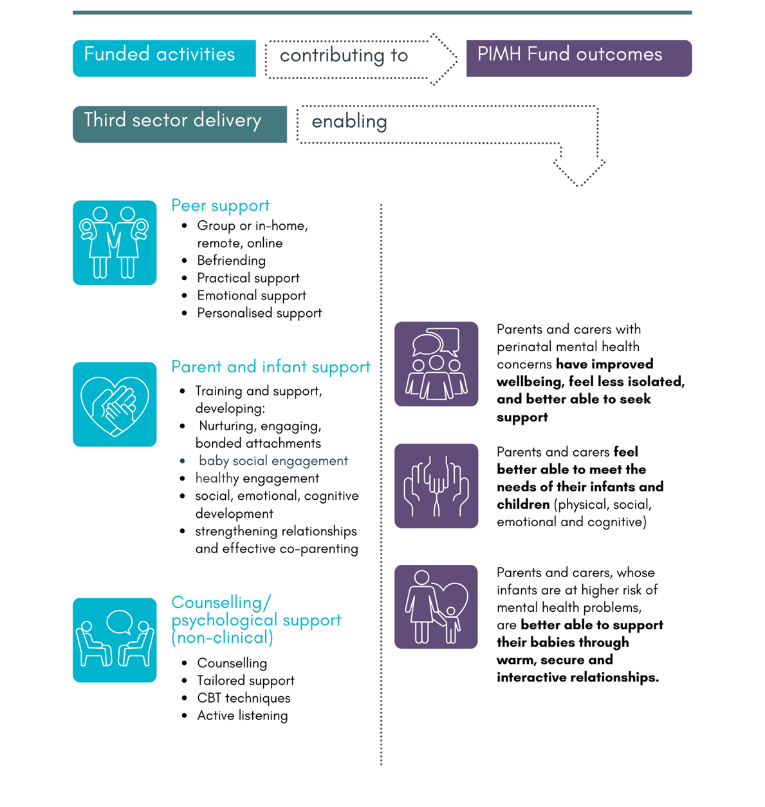

Figure 1: Funded activities and outcomes

Measuring impact
In your application form, you will be asked which of the outcomes your work supports. You can select one, two or all three.
All successful applicants will be required to report on progress against their chosen outcomes on a six-monthly basis. Some example indicators that organisations may use to measure progress towards fund outcomes are in the table below (figure 2).
Applicants will be asked to tell us how they intend to measure the difference their activities are making towards the fund outcomes and which indicators they will use to measure this difference.
Outcome | Example evaluation indicators
Parents and carers with perinatal mental health concerns have improved wellbeing, feel less isolated, and better able to seek support | - Attendance and engagement with support services  - Increased social support networks  - Frequency of social interactions  - Self-reported isolation levels  - Reduced anxiety  - Confidence in accessing support  - Knowledge of other sources of support  - Shared experiences with other parents/carers (less stigma)
Parents and carers feel better able to meet the needs of their infants and children (physical, social, emotional and cognitive) | - Access to, and use of, support services  - Better coping strategies / lower levels of stress  - Confidence and belief in parenting (self-efficacy)  - Knowledge of child development  - Increased feelings of attachment and bonding  - Parental/Carer satisfaction
Parents and carers, whose infants are at higher risk of mental health problems, are better able to support their babies through warm, secure and interactive relationships. | - Positive parent/carer-infant interaction  - Parental/Carer confidence and self esteem  - Responsiveness to baby’s cues  - Reported feelings of attachment, bonding and emotional connection  - Communication between parent/carer and infant  - Mutual enjoyment from relationship
Figure 2: PIMH 2024 Fund outcomes and example evaluation indicators

PIMH 2024 Fund outcomes: contribution to national context
The PIMH 2024 Fund outcomes have evolved from the original fund outcomes and contribute towards the Joint Strategic Board for Children and Family Mental Health and revised Scottish Government Mental Health and Wellbeing Strategy (2023).
The Scottish Government’s Mental Health and Wellbeing Strategy is based on a ‘life stage’ approach (as shown in figure 3). This means it is focused on prevention, early detection, recovery and treatment of mental illness and poor mental wellbeing, identifying opportunities for minimising risk factors, enhancing protective factors and providing appropriate support at important life stages.

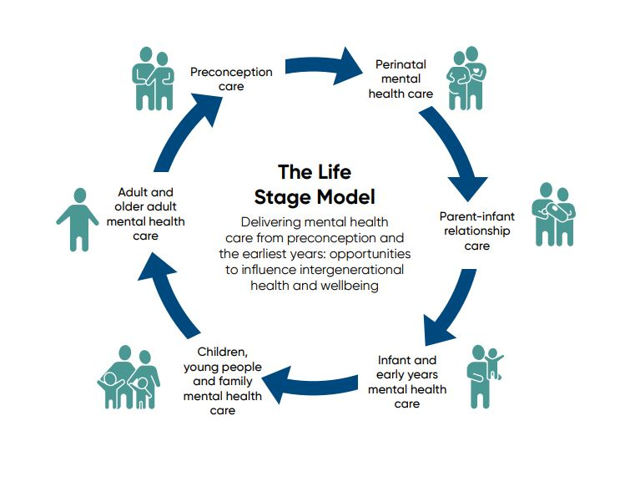
Figure 3: The Life Stage Model

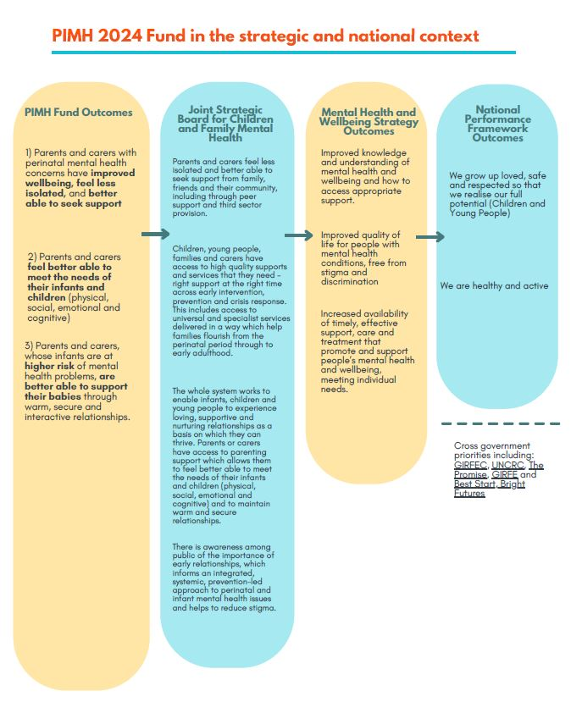

Figure 4: PIMH 2024 Fund outcomes in the strategic and national context

PIMH 2024 Fund application information

Fund duration
The PIMH 2024 Fund will run for 18-months, from October 2024 through to March 2026.
- Year 1 of funding will run for 6 months from October 2024 to March 2025.
- Year 2 will run from April 2025 to March 2026 in line with the 24/25 and 25/26 financial year.

Funding available
A total amount of up to £1,500,000 across the 18-months will be available for the PIMH 2024 Fund.
It is anticipated that maximum awarded grant for the 18-month period will be no greater than £132,000 being: £44,000 for six months in 2024-2025 and £88,000 for 12 months in 2025-2026.
Please remember that Year 1 of the Fund is for six months when you are planning your budget and funding request. Payments will be made to successful organisations on a quarterly basis in advance.
To enable support to reach more organisations, the PIMH 2024 Fund Decision Making Panel intends to award funding in three different band levels:
- Band 1: between £100,000 - £132,000
- Band 2: between £50,000 - £99,999
- Band 3: up to £49,999

As a guide we anticipate being able to fund between five to eight applications within each band.
Organisations may be asked as part of the assessment process whether they would accept being offered a part grant or whether they would be aiming for only the full amount requested.
Please note, all funding is subject to the Scottish Government annual budget process and any offers of grant will be indicative for 2025-2026 until the budget has been passed by the Scottish Parliament. Funding is also subject to any governance concerns raised by Scottish Government Policy Officers, or the organisations themselves.

Expectations of successful applicants
Successful applicants will be required to monitor, evaluate, and report on funded work on a six-monthly basis to the Scottish Government via the Fund Manager.
It is expected that any concerns, issues, or problems during the funding period will be brought to the attention of the Fund Manager early to allow for the necessary support to be put in place in a timely manner.

Application support available
Support is available throughout the application period from Inspiring Scotland. Please contact pimhenquiries@inspiringscotland.org.uk with any questions.
Surgery sessions: Inspiring Scotland will provide 30-minute virtual support sessions for organisations to discuss application queries. Inspiring Scotland will promote these sessions on the Inspiring Scotland website.
Frequently asked questions: An FAQ document is available on the Inspiring Scotland website. This will be updated as different queries are submitted.
Information via twitter (X): Updates and information on the Fund will be made regularly through @PIMH Fund - https://twitter.com/PIMHFund

Assessment and decision making process
- Applications submitted via online form by 12pm (noon) on 3 May 2024
- Inspiring Scotland will check applications for completeness and contact applicants for any additional information required
- Inspiring Scotland will undertake an assessment of all applications. The assessment will cover areas such as:
  - Eligibility of applicant organisation(s)
  - Organisational management and governance arrangements
  - Proposed activities fit with Fund aim and criteria
  - Accessibility of services
  - Safe and responsible practice
  - Impact and evaluation
  - Budget
  - Assessed applications will then be reviewed to look at the balance of proposals across Scotland, how the breadth of proposed work delivers the aim of the programme and how the needs of specific groups are being met.
  - Final decisions on funding will be made by the Decision Making Panel chaired by Scottish Government, featuring a range of PIMH Experts including third sector input, clinical input, perinatal mental health, and infant mental health input.

Fund priorities and decision making considerations.
We understand the high levels of demand facing PIMH services in Scotland and anticipate that the PIMH 2024 Fund will be oversubscribed.
A total amount of up to £1,500,000 is available across the 18-months of the PIMH 2024 Fund. This will be split into:
- Up to £500,000 for the six months of funding in the 2024-25 financial year, and
- Up to £1million for 12 months of funding in 2025-2026.
Having limited funding means the decision-making panel will consider the following:
- Geographic coverage: we will seek to fund a range of organisations across Scotland, with an ambition of supporting a service across all Health Board areas whilst also considering population bases, birth rates and local access to other services.
- Prevention and early intervention: we will seek to fund organisations who are supporting babies, parents and carers who are at a higher risk of developing perinatal and infant mental health issues. This could include family-based risk factors such as family types identified to be at the highest risk of child poverty, or factors such as parental substance use, family violence, parental conflict or separation.

When deciding which applications to fund, the Decision Making Panel will aim to ensure that a wide range of services for babies, parents and carers, including those with protected characteristics or additional vulnerabilities are supported.

Key Dates
March / April
Expression of interest forms live  Fund information, FAQs and the application form template available from https://inspiringscotland.org.uk/fund/perinatal-infant-mental-health-fund-2024 | Mid-March
Application support available from Inspiring Scotland
May
Applications due by 12pm (noon) on Friday 3 May  This is a fixed deadline and there will be no exceptions. Please submit in advance if possible. | 3 May
Applications assessed by Inspiring Scotland

June
The Decision Making Panel is scheduled to meet in June, with decisions communicated as soon as possible after the meeting | June
October
Grant set up and first fund payments made | October

SECTION 2 - Guidance on completing the PIMH 2024 Application

Please use the Word template to draft your answers. It has all the questions that are in the application in bold, with guidance of the types of information we are looking for in each answer.
When you are ready to submit your application, you will need to do so via the online application form. You will receive a link to the online application form once you have registered your interest.
If applying online is a barrier to you, please contact Inspiring Scotland in advance of the due date, as alternative application methods are available.

When drafting your application:
- Please refer to the Fund Guidance Notes and FAQs.
- Please take note of the guidance provided for each application question.
- Note some questions have word limits for answers. If you go over the word limit you will not be able to submit your application.
When you are ready to submit your application:
- Copy and paste your answers into the online form. You will also need to upload:
- A copy of your organisation’s constitution
- A copy of your latest audited accounts
- A copy of your application budget
For technical support with the online form please refer to our Technical Guidance Notes.
The final deadline for applications is 12pm (noon) on 3 May 2024. You can submit your application at any time before this but no later than this date and time.

Part 1 – Tell us about your organisation.

- Please provide details of the organisation making this application
You will need to provide details of the organisation applying including the legal status, charity and company registration numbers, and registered address.

- Please provide two contact details for your application
We require a primary and secondary contact for the application

- Does your bank account require two signatories to make withdrawals?
To be eligible to apply, your bank account must require two signatories for withdrawals.

Yes/No

- Is this a partnership application?
If you are applying in partnership provide the organisational details of all other partners.

- Have you been funded through the PIMH Fund previously?
Yes/No
If No is selected, please answer:

5a. What is the mission, purpose, and main activities of your organisation?
Question type: Open text up to 500 words. In your answer, please tell us: your organisation’s main activities, details of the perinatal and infant mental health services or activities you currently deliver, about who you support

- Which of the following organisational policies do you have in place?
Select the policies you have in place from the check boxes provided.
- Safeguarding (for children and young people and/or vulnerable adults)
- Data protection (GDPR)
- Equality and diversity policy
- Health and safety
- Risk management
- Financial procedures (conduct)
- Disciplinary and grievance
- Complaints
- Conflict of Interest
- Whistle blowing

- Tell us about your governance, leadership, and management arrangements
Question type: Open text up to 500 words. In your answer, please tell us:
- about your senior management structure and how it reports to the Board;
- what skills do you have on your board, how many people are on your board, and how frequently the Board meets;
- what financial oversight your Board has;
- about any designated responsibilities or sub-committees and how often they meet
- about any lived experience representation both at management level and on the Board;
- how you handle any situations involving conflict of interest;

- If you are a Community Interest Company (CIC), tell us how you ensure separation of duties and manage conflicts of interest when dealing with employment and performance related issues.

8. Please upload your latest set of annual accounts and tell us about the funding you receive to support perinatal and infant mental health activity.
Question type: Open text up to 350 words

In your answer please tell us:
- if there are any major updates in terms of income, expenditure and level of reserves from the set of accounts submitted
- what funding you have to deliver perinatal and infant mental health activity (who funds you and for how long) and if you have any contracts with Local Authorities, HSCP’s or Health Boards;
- the percentage of your annual income a full year of your PIMH 2024 Fund request represents

9. Is your organisation currently in receipt of Scottish Government grant funding?
Question type: Yes or No check box
If yes is selected, please answer
9a. Please tell us about the other sources of Scottish Government funding you receive.
Question type: Open text
In your answer tell us:
- the name of the fund (or Directorate it comes from)
- the amount received per year
- how long you expect to receive this funding for

9b. Do you have any other funding applications to Scottish Government currently pending?
Question type: Yes or No check box

If yes is selected, please answer
9c. What other funding have you applied to the Scottish Government for?
Question type: Open text
In your answer, tell us:
- the funding source including title and
- amount per year applied for

10. Uploads
Please upload:
- A copy of your constitution

Part 2 – Tell us about the activities you would like funding for

11. Please give us a summary of the specific activities you will deliver with the funding you are requesting (300 words)

12. Please select what types of activity you are requesting funding for:
Question type: Select all relevant checkboxes from:
- Peer support
- Parenting and infant support
- Counselling and psychological support
- Other

13. Describe who will use your service and how they will access it
Question type: Open text up to 500 words
In your answer, please tell us:
- about your service users, including if you are working directly with babies as your primary beneficiaries
- if your activities are targeted at groups that are at higher risk of developing perinatal and infant mental health concerns – what these risk factors are
- where you get your referrals from and/or how people will know about your service
- if relevant, who you do not work with and where you would refer to

14. What evidence do you have that the activities you describe are needed for the people you are supporting?
Question type: Open text up to 400 words
In your answer, please tell us:
- about demand for your services
- what evidence you have that the support you deliver matches the needs of your service users
- why these activities are being delivered
- what gaps in provision your activities address locally

15. Please tell us more about your approach to delivering the PIMH activities that you are seeking funding for
Question type: Open text up to 500 words

In this question we are looking for information on:
- your assessment process and criteria for determining how you will support families
- how long you support families for
- once support is complete, the process for supporting families to exit your service
- other organisations you might work with or refer people to
- if you are applying in partnership with another organisation, please tell us more information about how you and your partner organisations will work together
- if your proposal is to provide training, consultancy or supervision, please give more information on the type of training or support you offer and how you will deliver this
If relevant to your organisation, your answer may also include:
- how you take a whole family approach to delivering support
- how you take a strengths-based approach when delivering activities
- how your activities take a holistic view to tackling barriers caused by inequality of income and poverty
- how you deliver support in line with Getting it Right for Every Child (GIRFEC)

16. How do you ensure that your service is accessible? (300 words max)
Please tell us:
- The demographics of your current service users
- How you monitor who is using your service
- What you do to proactively address barriers to your service for people from different communities and marginalised groups, and those with additional vulnerabilities (including neurodiversity)

17. How many people do you estimate will be supported through this funding across the 18-month duration?
Question type: text boxes
Year 1: October 2024 – March 2025 (6 months)
Year 2: April 2025 – March 2026 (12 months)

Please note that the figure is to reflect the number of people impacted by the PIMH 2024 Funding you are seeking, and not by your service or organisation in full. For example, if you are applying for core funding and the application request represents is 20% of your total revenue, the anticipated number of people supported can be 20% of your total organisational beneficiaries
18a. What Local Authority area(s) will you provide the activities you are requesting funding for?

18b. What NHS Health Board area(s) will you provide the activities you are requesting funding for?

19. Please describe your training, accreditation and supervision arrangements for all staff and volunteers delivering activities
Question type: Open text up to 400 words
In your answer, please tell us:
- about your training and supervision arrangements
- how potential risks are managed and mitigated
- how your organisation operates with a trauma-informed approach and any trauma -informed levels staff are working at
- if relevant, how organisational training is in line with NHS Education for Scotland Psychological Therapies Matrix and Perinatal Mental Health Curricular Framework

20. How do you ensure your activities take account of the views of people with lived experience of perinatal and infant mental health issues?
Question type: Open text up to 200 words
In your answer, please tell us:
- what you do to ensure your activities are informed by people who are accessing them

21. Tell us about how you work collaboratively with other organisations and services
Question type: Open text up to 200 words
In your answer, please tell us:
- how you appropriately signpost and refer to other local organisations
- how you work jointly with others
- what local groups, collaborations, membership bodies you are part of and what strategic groups you contribute to
- how you are linked in with local advisory groups

Only answer this question if you selected Counselling and psychological support in Question 12.
22. If you provide counselling or psychological support for parents experiencing perinatal mental health issues and/or therapeutic support for infants, please tell us a bit more about the therapies you engage.
Question type: Open text up to 400 words
In your answer, please tell us:
- what the evidence base is for your therapeutic work
- the rationale for why those therapies have been chosen for the people you work with
- what specific training, qualifications or accreditation staff who deliver these therapies have

23. The PIMH 2024 Fund will measure the difference this funding makes for parents, carers and babies across three Fund Outcomes.

Please tell us which of the outcomes this activity will contribute to (you can select more than one):
Question type: Select all relevant checkboxes from:
- Parents and carers with perinatal mental health concerns have improved wellbeing, feel less isolated, and better able to seek support
- Parents and carers feel better able to meet the needs of their infants and children (physical, social, emotional and cognitive)
- Parents and carers whose infants are at higher risk of mental health problems, are better able to support their babies through warm, secure and interactive relationships

24. How will you measure the difference that your activities are making for parents, carers and babies?
Question type: Open text up to 750 words
In your answer, please refer to the fund outcomes and potential indicators, and tell us:
- the methods or tools you use to collect information about the impact your activities is having? e.g. Survey, observations, interviews
- what you will measure or what information you will gather (indicators)
- how often you will gather feedback and evaluation information and
- how you will analyse and act on your findings

Part 3 – tell us about the budget and funding request
25. How much are you applying for? Please select which band your total funding request fits in:
Question type: Select the relevant checkboxes from:
- Band 1: between £100,000 - £132,000
- Band 2: between £50,000- £99,000
- Band 3: up to £49,999

Total amount of funding you are requesting across the 18-month period. Please note applicants can apply for a maximum amount of £132,000 for the duration of the 18-month fund
Question type: Open textbox

26. Are the total costs of delivering your proposed activities more than the amount you are requesting from PIMH 2024?
Question type: Yes or No checkbox
If yes is selected, please answer

26a. What other funding will contribute to delivering proposed activities?
Question type: Open text
In your answer, tell us:
- the funding source
- whether that funding is already secured
- how much funding this will contribute
- what it will pay for

27. Activity budget
Please upload a full budget, that outlines all expenditure that you are requesting PIMH 2024 Funds for. Please use the budget template provided.
- Please make the budget as detailed as possible
- Please provide a rationale for how any contribution to overheads has been determined
- Please provide a break-down for any budget line over £5,000 (apart from staff salaries)
- Please factor in any salary uplifts required for the financial year 2025-2026 in line with the Fair Work requirements
- Please show how proposed expenditure is split across organisations working in partnership

28. Are you seeking funding to pay for staff?
Question type: Yes or No checkbox
If you are, please tell us about the staff roles you are requesting funding for.
28a. What staff are you seeking funding for?
Question type: Text boxes
Complete a new line for each individual member of staff, even if there will be more than one doing the same role

Job title
FTE salary (£)
Hours pw to be funded through PIMH 2024
Funding requested for role

28b. Please confirm by ticking the box that the above salaries meet at least the National Living Wage
Question type: check box

28c. Are you an accredited living wage employer?
Question type: check box

Part 4 – authorisation

I/we apply on behalf of the organisation named above for a grant as proposed in the application in respect of expenditure to be incurred over the proposed funding period on the activities described above.

I certify that, to the best of my knowledge and belief, the statements made by me in this application are true and the information provided is correct.

The PIMH 2024 Fund is a Scottish Government programme with the application process managed by Inspiring Scotland. By submitting this application, I, give consent that information in this application form can be shared in confidence with the Scottish Government for the purposes of assessment, decision making, publicity, or promotion of any award.

The Scottish Government is subject to the provisions of the Freedom of Information (Scotland) Act 2002 please therefore note that information provided may be disclosed in accordance with this legislation.

Name of authorised person:

Position of authorised person:

A note on privacy and personal data:
Inspiring Scotland recognises its obligation to handle personal data it collects and uses in accordance with data protection legislation and best data protection practices. We will only collect personal data which is necessary for us to do our job and where we have a legitimate interest in doing this. By completing this form, you are agreeing to the terms of Inspiring Scotland’s privacy statement found here https://www.inspiringscotland.org.uk/privacy-statement/ . Any questions regarding this Policy and our privacy practices should be sent by email to enquiries@inspiringscotland.org.uk

Use of Artificial Intelligence:

Inspiring Scotland may make use of Artificial Intelligence (AI) tools to support the administration and management of the application process. This would be limited to using AI supported processes to assist with the coding, analysing and summarising funding proposals. It will not be used to store or analyse any personal or commercially sensitive data. Where AI is used, any decisions or recommendations suggested by the AI will be checked and validated by fund staff prior to being acted on.

If you do not want information you provide in your application to be used in AI technology, please opt out by ticking this box.

Technical guidance for completing the online application form

Before you apply online, we recommend that you download and draft your answers on the Microsoft Word template. This will let you plan and prepare your answers offline before you copy and paste them into the online form.
Please note that the online form will not recognise text formatting (including bold text and bullet points) when you copy and paste your answers into the online form. It will recognise new paragraphs but we recommend checking you are happy with your formatting before you submit online.
At the time of submitting your application online, please also have ready copies of the following documents ready to upload:
- The latest set of accounts for all organisations who will deliver the activities detailed in the application form
- A copy of your constitution
- A budget detailing costs of the work subject of the application

If you have any problems with uploading these documents please email:
PIMHenquiries@inspiringscotland.org.uk

Using the online form
You can save your progress by ticking the box at the top of the form. You will be asked to enter your email address and to make a password. The system will then send you an email with a link to return to your work. Depending on the security settings your organisation uses, this email may be blocked or marked as spam. If you do not receive an email within a few minutes, check your spam/junk folders. If you don’t receive an email at all contact Inspiring Scotland on PIMHenquiries@inspiringscotland.org.uk and we can send you the link to access your application.

Make sure to always use the same email address when using the ‘save and continue later’ function, i.e. do not use one address to save at first and then another later in the form.

After answering the final section of the form, there is an option to review all your answers. You can also download a PDF of your completed form.

Once you have submitted your form, you will receive an email confirming it has been received. The email will contain a PDF of the completed form. As with the save
and continue function, this email may be blocked or marked as spam, depending on your security settings. If you do not receive a confirmation email with a copy of your application, do not panic – we can check the system for you and provide this.

End Notes
- Estimates suggest that around 20% of mothers (Prevatt et al., 2018; Geller et al., 2018) and up to 10% of fathers (Cameron et al., 2016) experience poor mental health in the perinatal period
- Royal College of Psychiatrists Council Report: Infant and early childhood mental health: the case for action (CR238), October 2023
- Vasileva M, Graf RK, Reinelt T, Petermann, U and Petermann F (2020) Research review: A meta‐analysis of the international prevalence and comorbidity of mental disorders in children between 1 and 7 years. Journal of Child Psychology and Psychiatry: https://doi.org/10.1111/jcpp.13261
- The Robertson Trust Maternal Mental Health Research Briefing: https://www.therobertsontrust.org.uk/media/5xnbi0wk/2019_06_13_mmh_research_-_external_report_.pdf
- For more information on legal structures for third sector organistions, please see The Resource Centre (https://www.resourcecentre.org.uk/information/legal-structures-for-community-and-voluntary-groups/#:~:text=A%20charitable%20trust%20is%20not,the%20organisation%20is%20legally%20charitable.) or SCVO (https://scvo.scot/support/setting-up/structure). Unincorporated voluntary groups such associations and trusts have no legal personality and are not eligible to apply. If you have any questions, please speak to Inspiring Scotland directly (pimhenquiries@inspiringscotland.org.uk)

Resources
- Perinatal and Infant Mental Health Fund Update Report
- Mental Health and Wellbeing Strategy
- Mental Health and Wellbeing Strategy Delivery Plan
- National Performance Framework
- Women and Families Mental Health Pledge
- Infant Pledge and Voice of the Infant Best Practice Guidelines
- Getting it Right for Every Child
- Parent Club

Please note, all funding is subject to the Scottish Government annual budget process and any offers of grant will be indicative for 2025-2026 until the budget has been passed by the Scottish Parliament.
Estimates suggest that around 20% of mothers (Prevatt et al., 2018; Geller et al., 2018) and up to 10% of fathers (Cameron et al., 2016) experience poor mental health in the perinatal period
Royal College of Psychiatrists Council Report: Infant and early childhood mental health: the case for action (CR238), October 2023
Vasileva M, Graf RK, Reinelt T, Petermann, U and Petermann F (2020) Research review: A meta‐analysis of the international prevalence and comorbidity of mental disorders in children between 1 and 7 years. Journal of Child Psychology and Psychiatry: https://doi.org/10.1111/jcpp.13261
The Robertson Trust Maternal Mental Health Research Briefing
For information on legal structures for third sector organisations The Resource Centre or SCVO. Unincorporated voluntary groups such associations and trusts have no legal personality and are not eligible to apply. If you have any questions, please speak to Inspiring Scotland directly (pimhenquiries@inspiringscotland.org.uk)
Direct support - either face to face, online or via phone

